



All-pairs shortest paths using Floyd-Warshall
LAB MANUAL

Disclaimer: The content is curated from online/offline resources and used for educational purpose only
Compute all-pairs shortest paths using Floyd-Warshall and modify Floyd-Warshall to detect the presence of negative cycles

Objective:
To implement Floyd-Warshall algorithm to compute all-pairs shortest paths, reconstruct the paths, and detect the presence of negative weight cycles. Also, analyze how this feature can be integrated into real-world routing systems to improve reliability and safety.
Problem Statement:
Write a program to compute all-pairs shortest paths using the Floyd-Warshall algorithm. The program should support:
- Path reconstruction between any two nodes.
- Detection of negative weight cycles in the graph.
- Understand how negative cycle detection can enhance real-world routing systems.

Equipment Required:
- Python with Jupyter Notebook
- Libraries: No external libraries required (standard Python)

Prerequisites:
- Knowledge of dynamic programming
- Understanding of graph theory and shortest path algorithms
- Familiarity with path reconstruction and matrix operations
Procedure:
Step 1: Define Floyd-Warshall Algorithm with Path Reconstruction and Negative Cycle Detection
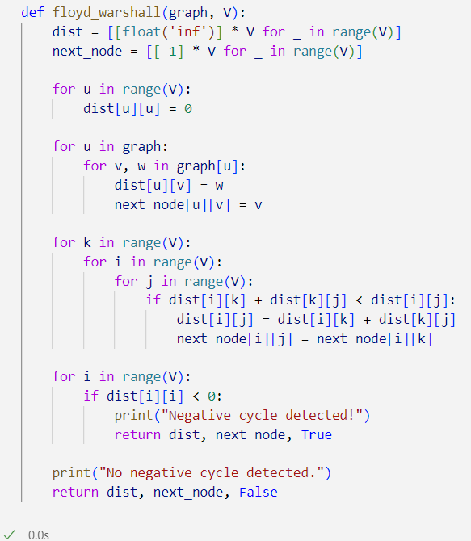

Step 2: Define Path Reconstruction Function
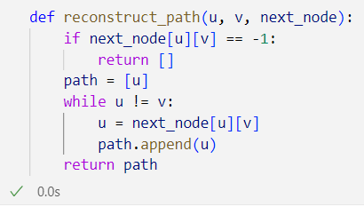
Step 3: Sample Graph and Execute the Algorithm
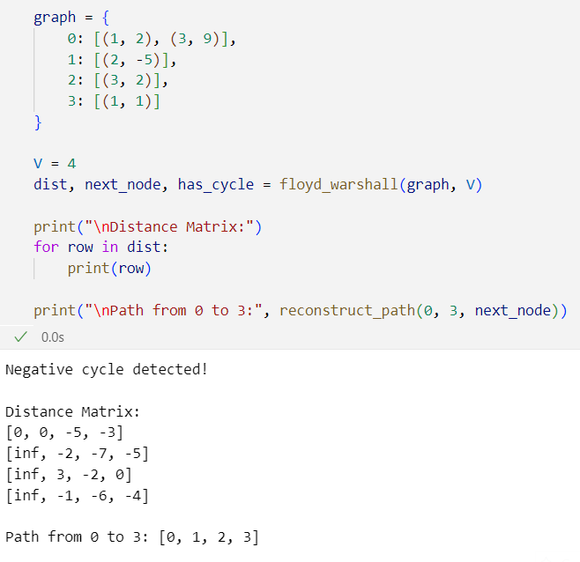

Output:
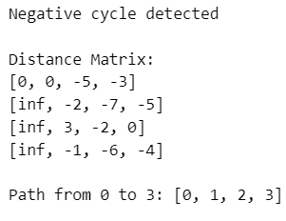
Conclusion
Negative cycle detection is crucial in:
- Financial routing systems: Prevents infinite arbitrage loops.
- Transport routing algorithms: Avoids logic failures where cost keeps decreasing unrealistically.
- Telecommunication networks: Prevents erroneous loop routing in cost-sensitive protocols.
Integrating this check ensures robust, error-free routing decisions and early alert to inconsistencies in data or logic.

